**ASSIGNMENT**

**BIOINFORMATICS BASED TOOLS FOR ANALYSIS OF PROTEOMICS DATA**

**Expasy Server**

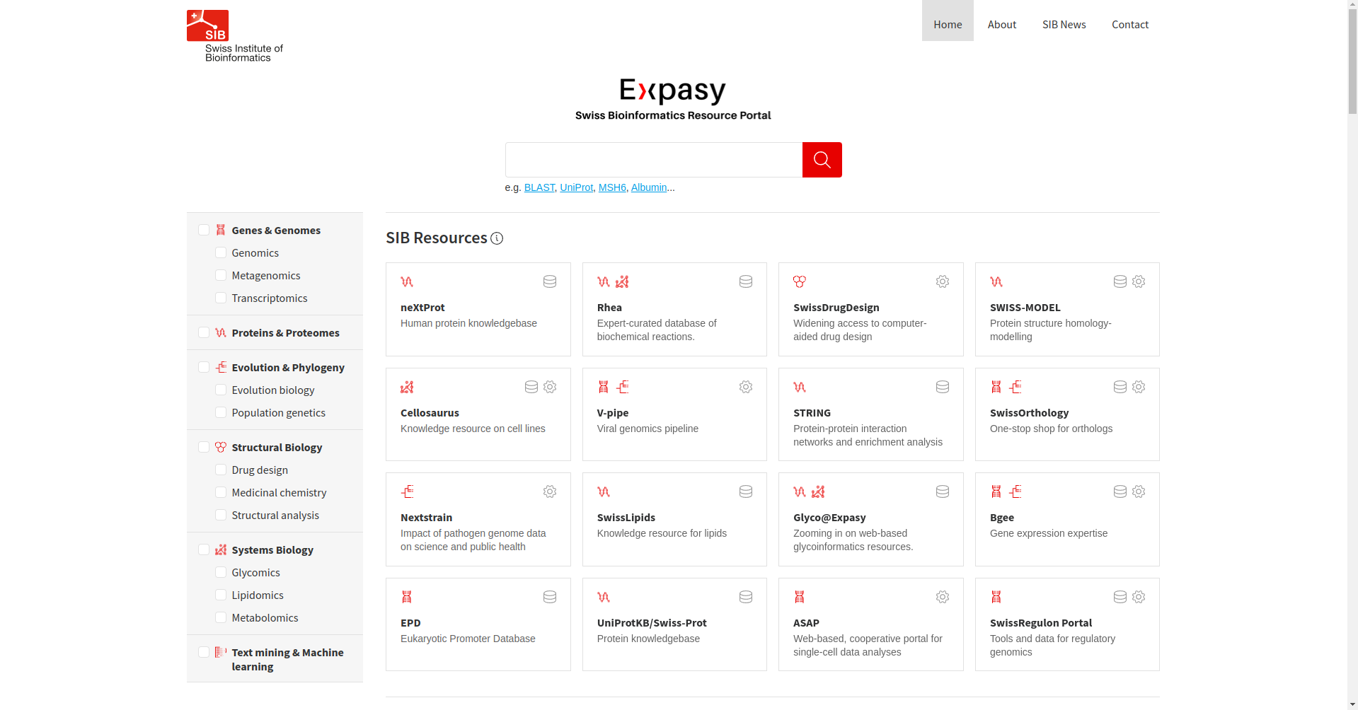

Fig1. Homepage of Expasy Server

**1. Compute pI/MW**

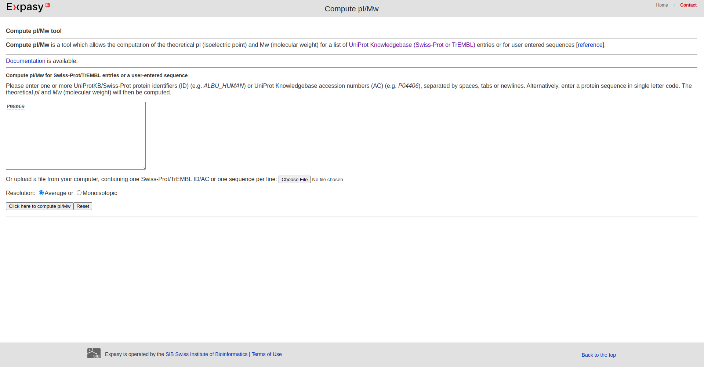

Fig2. Homepage of Compute pI/MW tool



Fig3. Website of Compute pI/MW Accession number : P08069

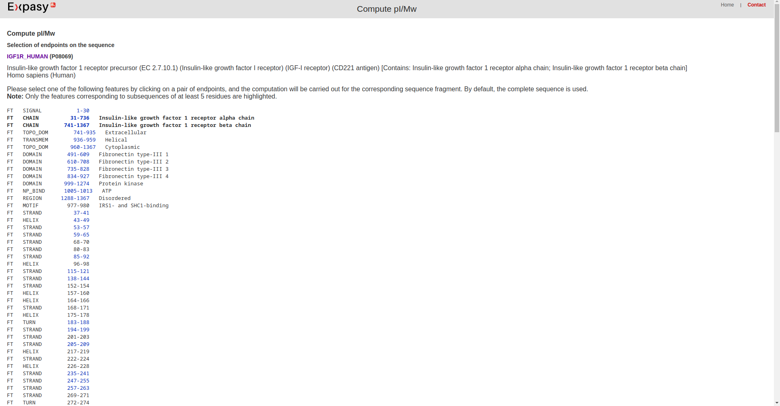

Fig4. Result of query

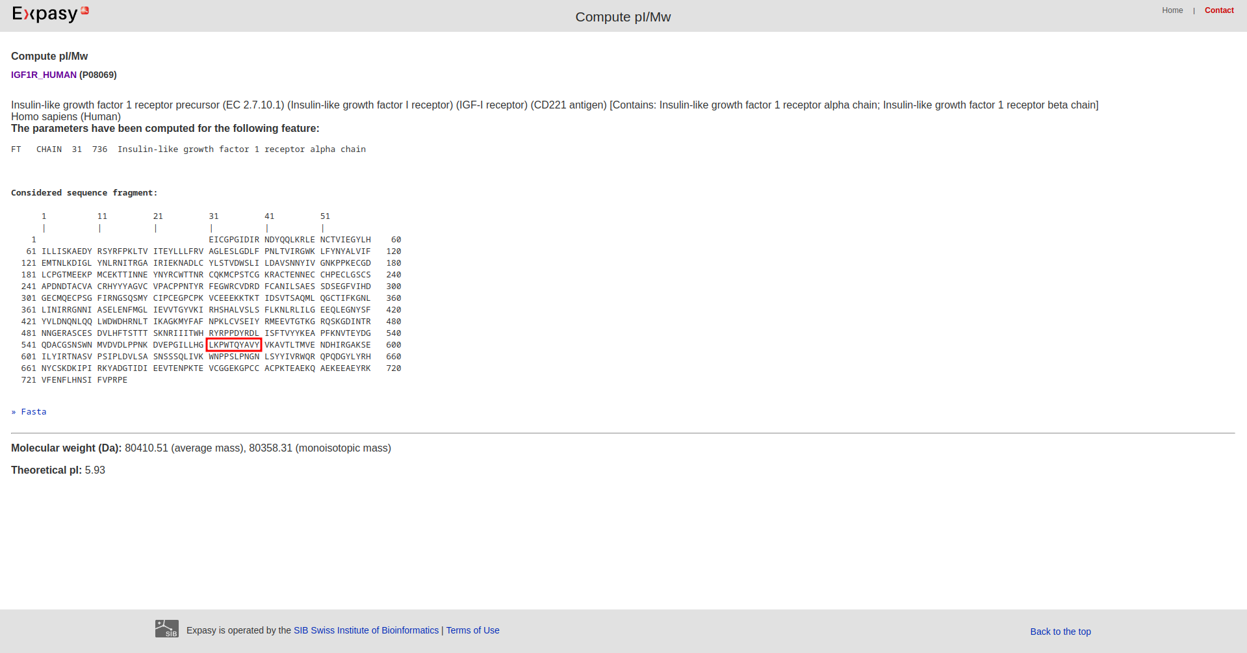

Fig5. Feature Chain

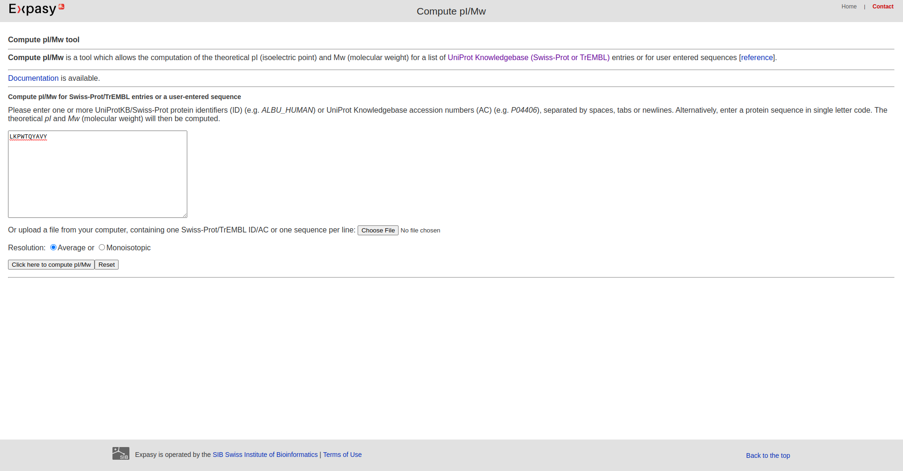

Fig6. Random unknown sequence entered to search for pI and MW

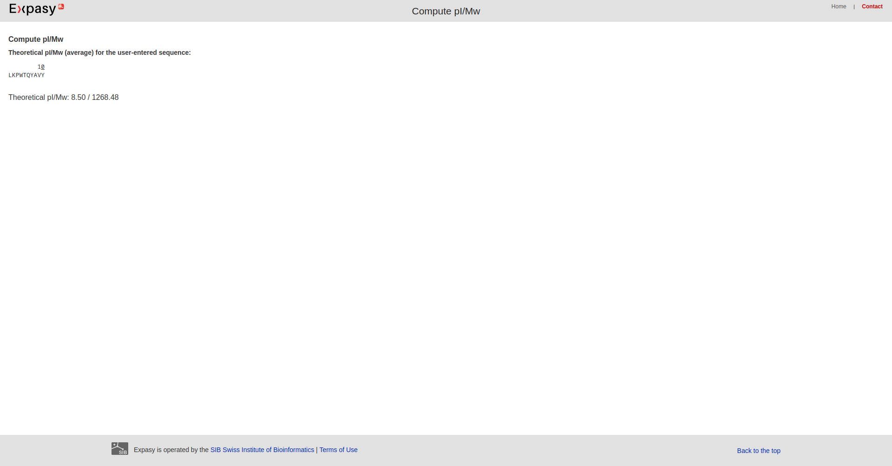

Fig7. Result page for random unknown sequence

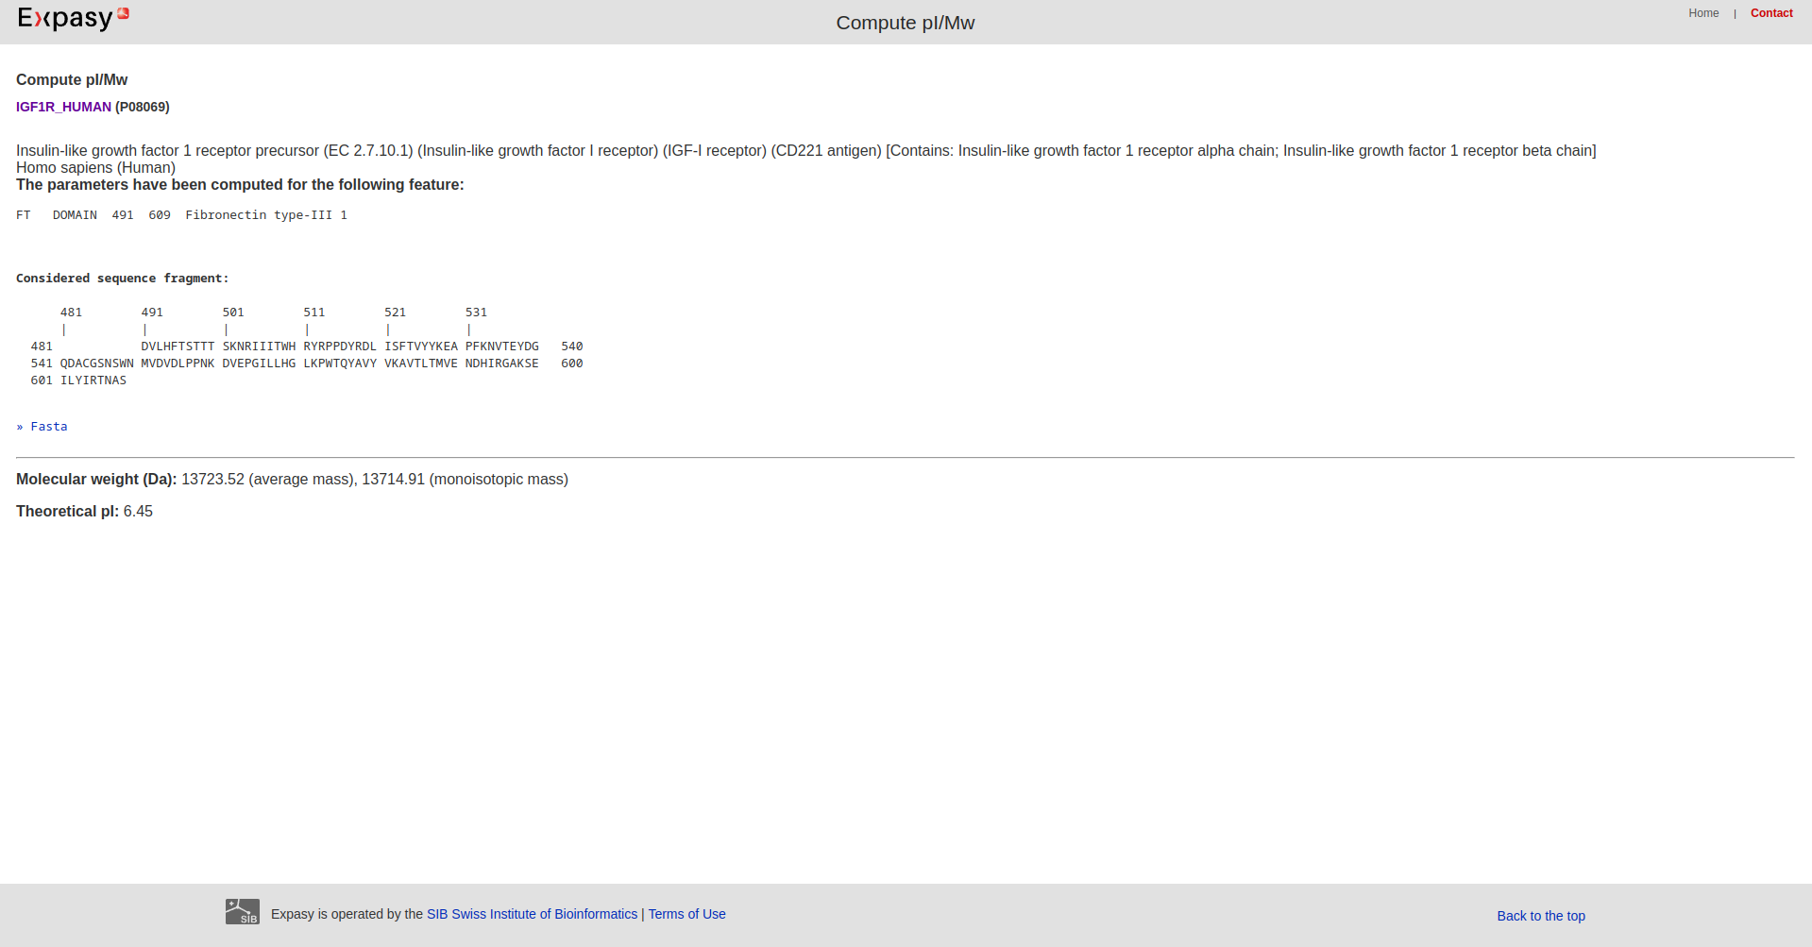

Fig8. Feature Domain

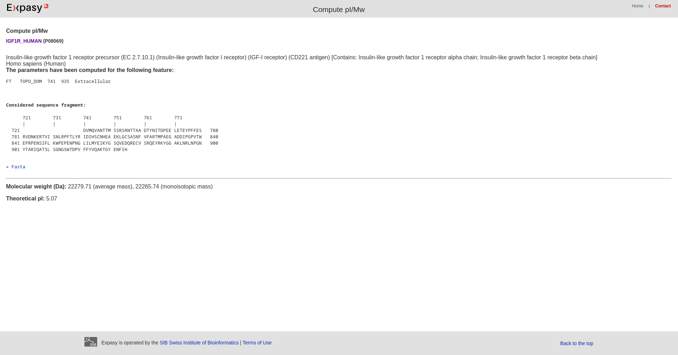

Fig9. Feature TOPODOM

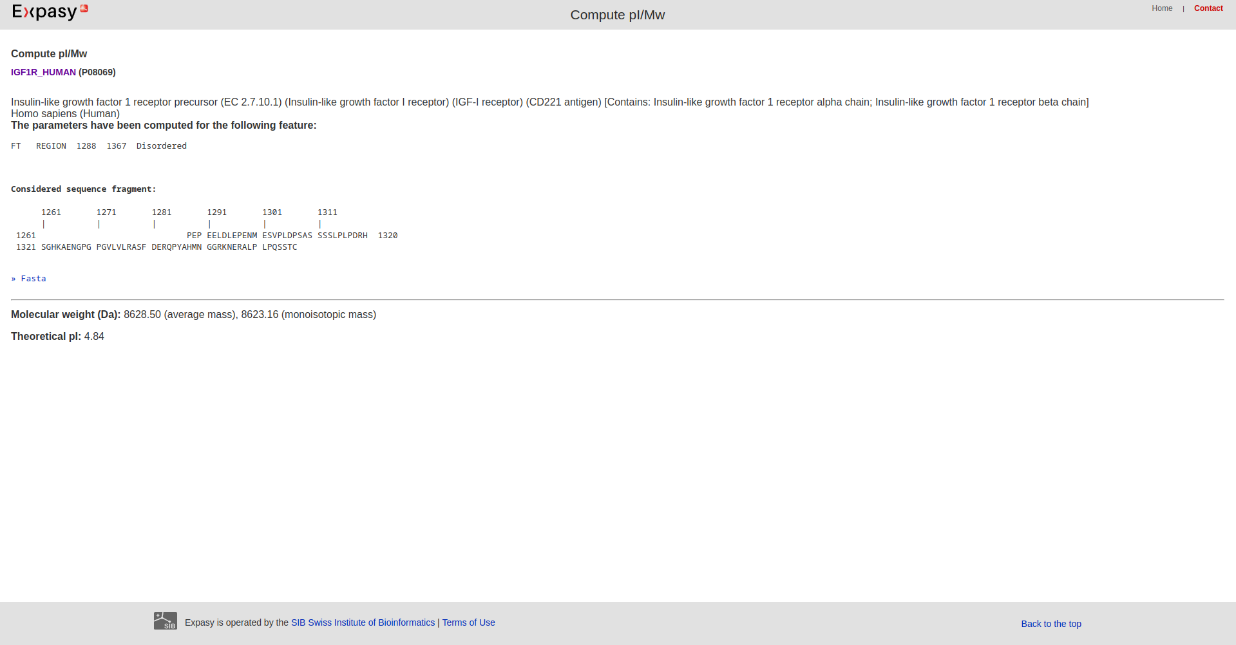Fig10. Feature Region

**2. ProtParam:**

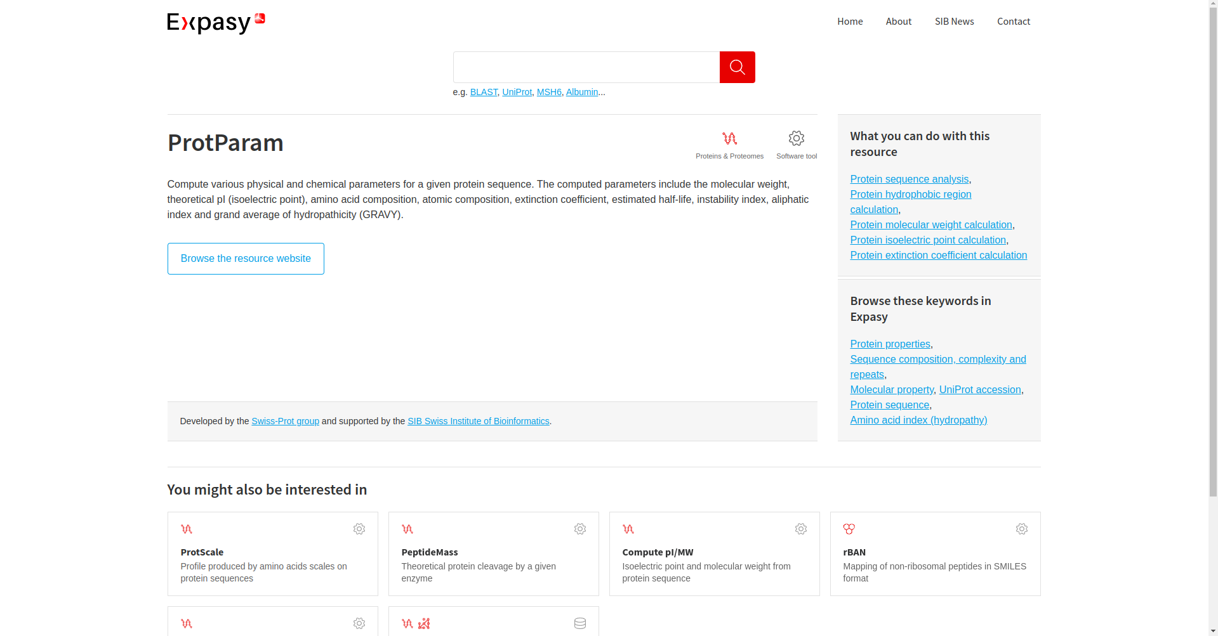Fig11. Homepage of ProtParam

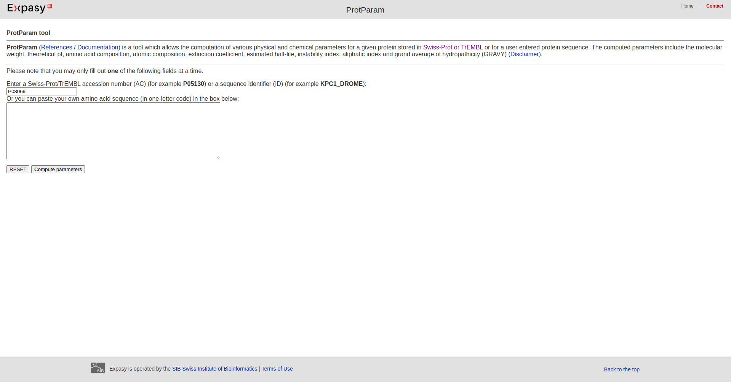Fig12. Website of ProtParam [Accession number: P08069]

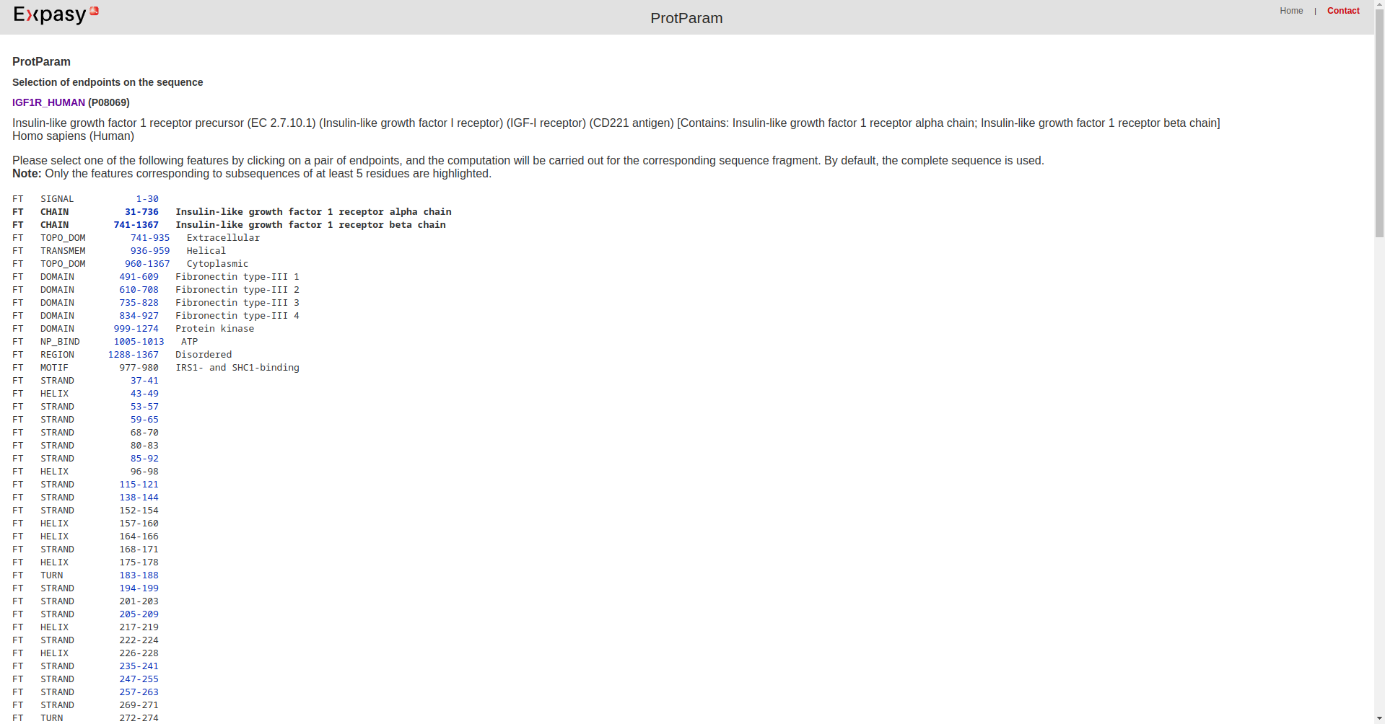Fig13. Result Page of Query

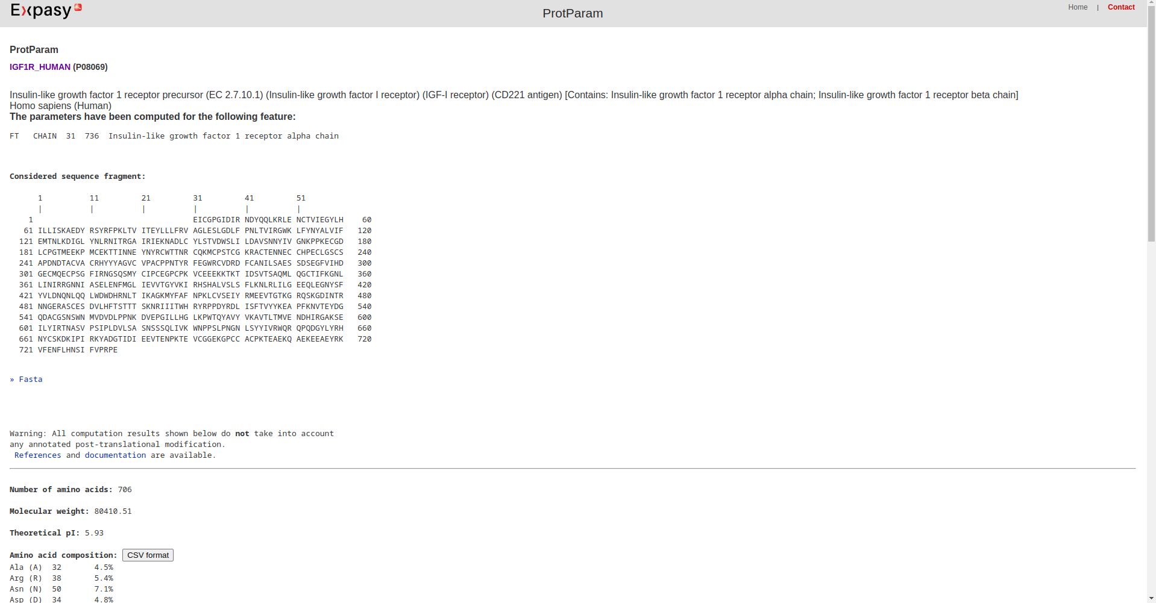Fig14. Feature: Chain

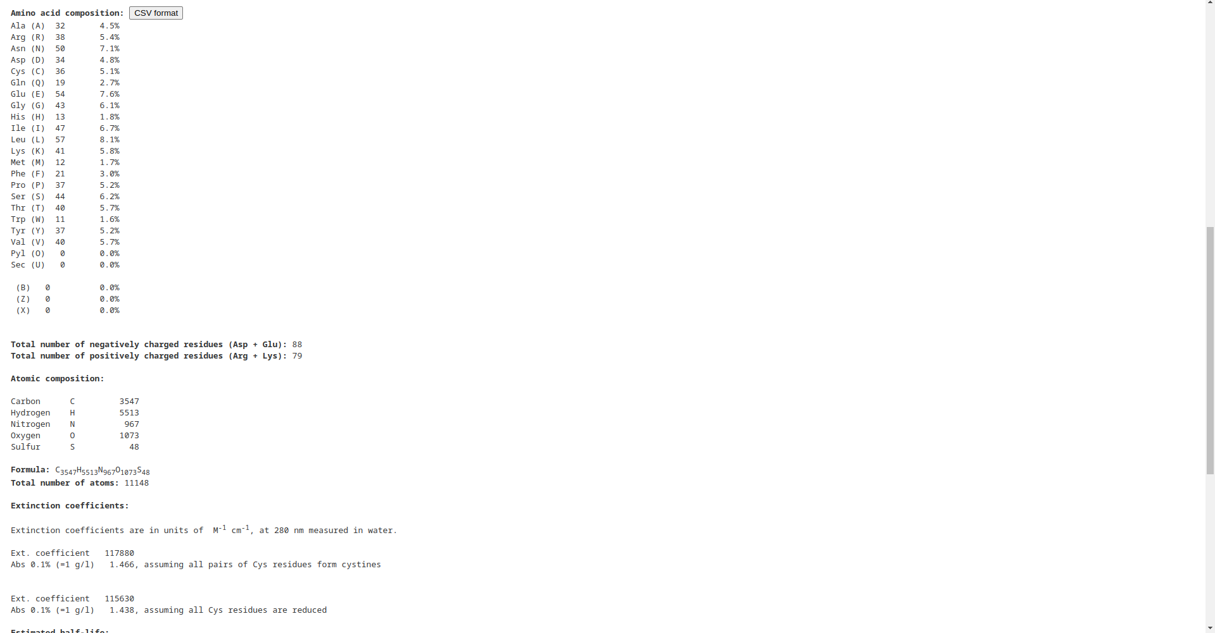Fig15. Feature Chain (cont)

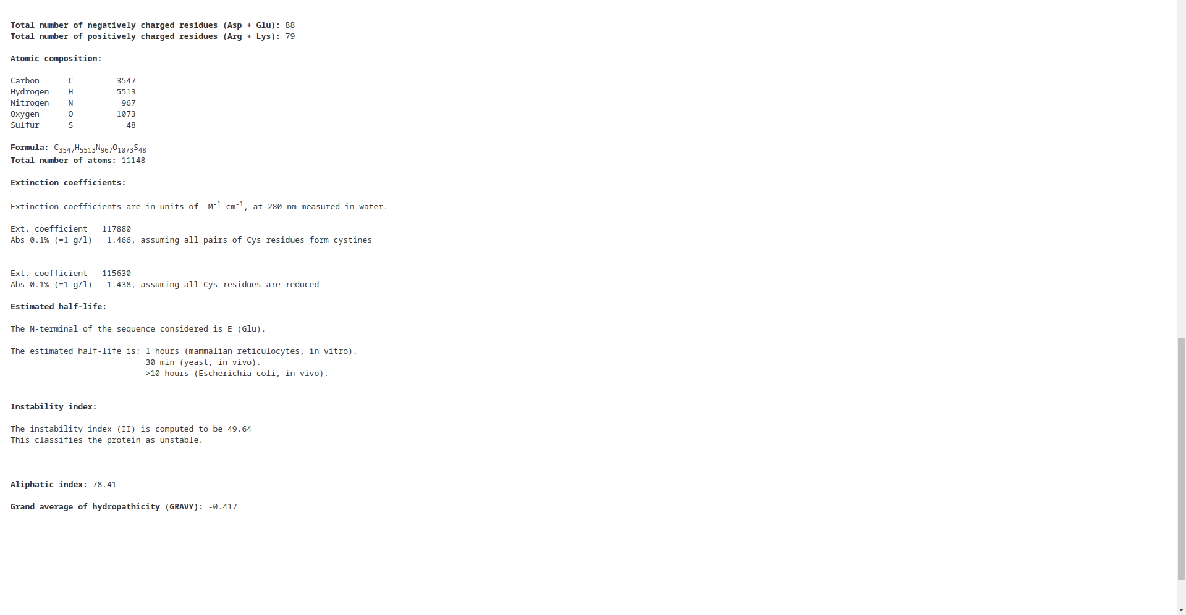Fig16. Feature Chain (cont)

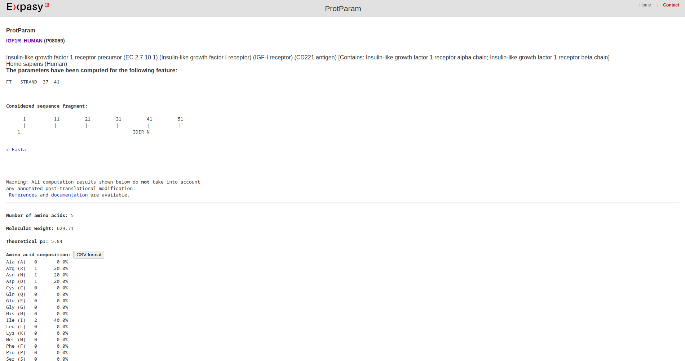Fig17. Feature Strand

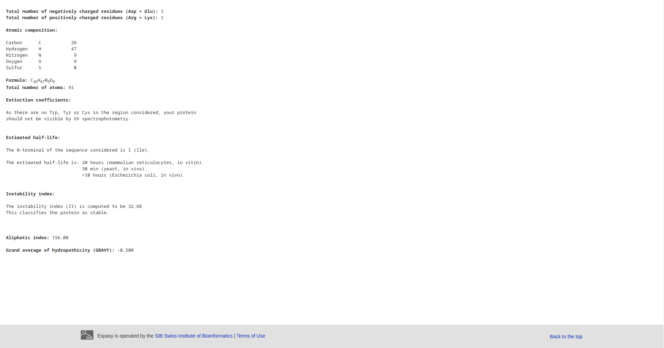Fig18. Feature Strand (cont)

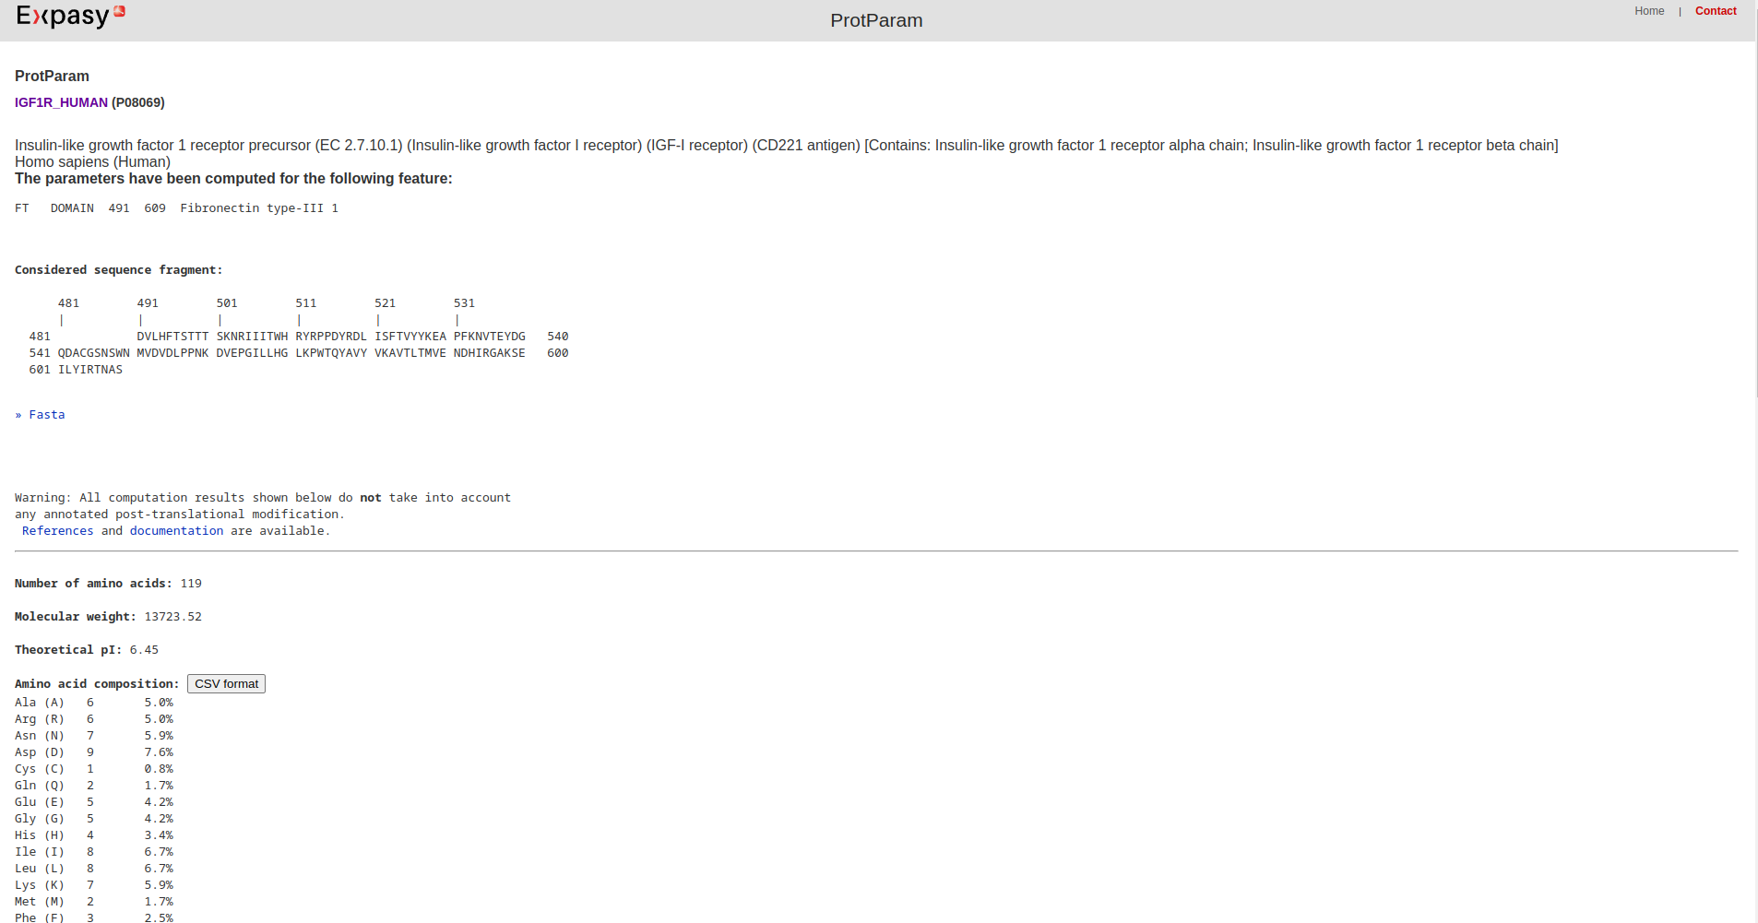Fig19. Feature Domain

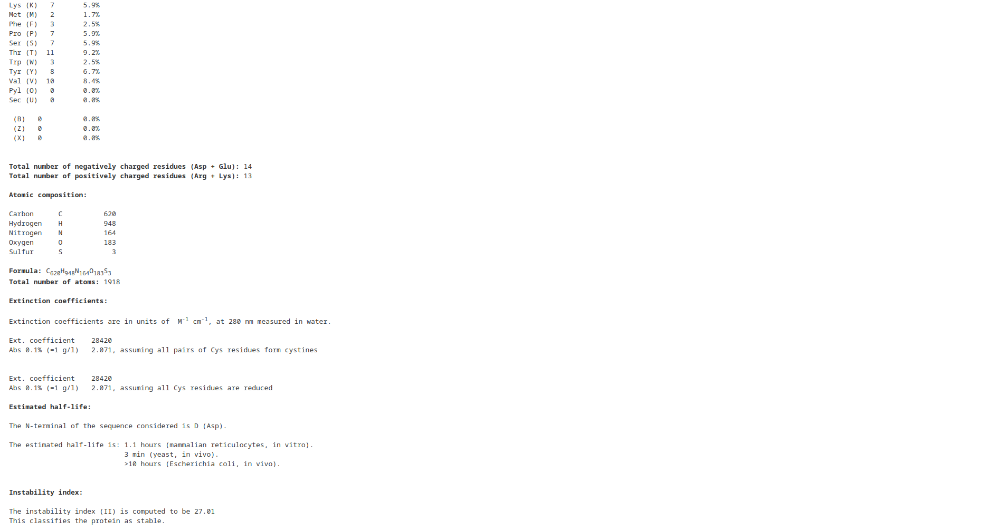Fig20. Feature Domain

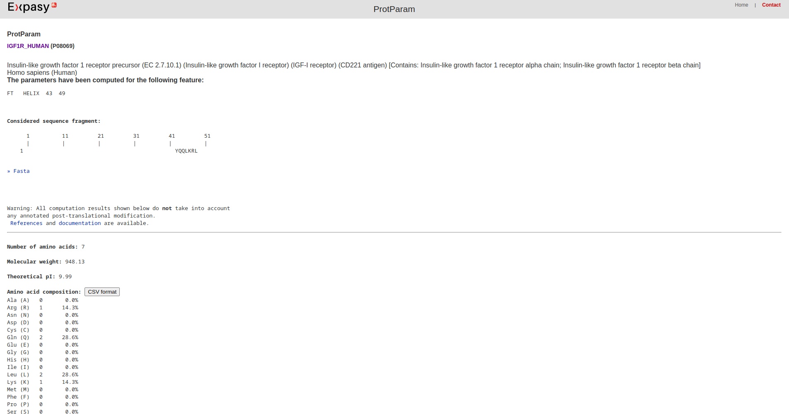Fig21. Feature Helix

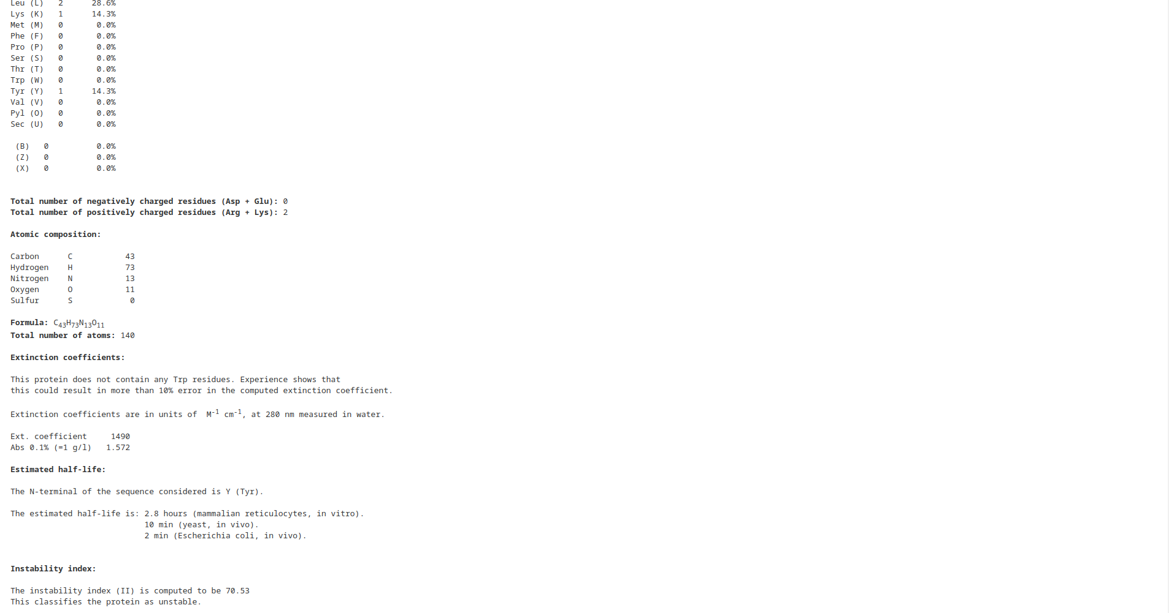Fig22. Feature Helix

**3. PeptideMass:**

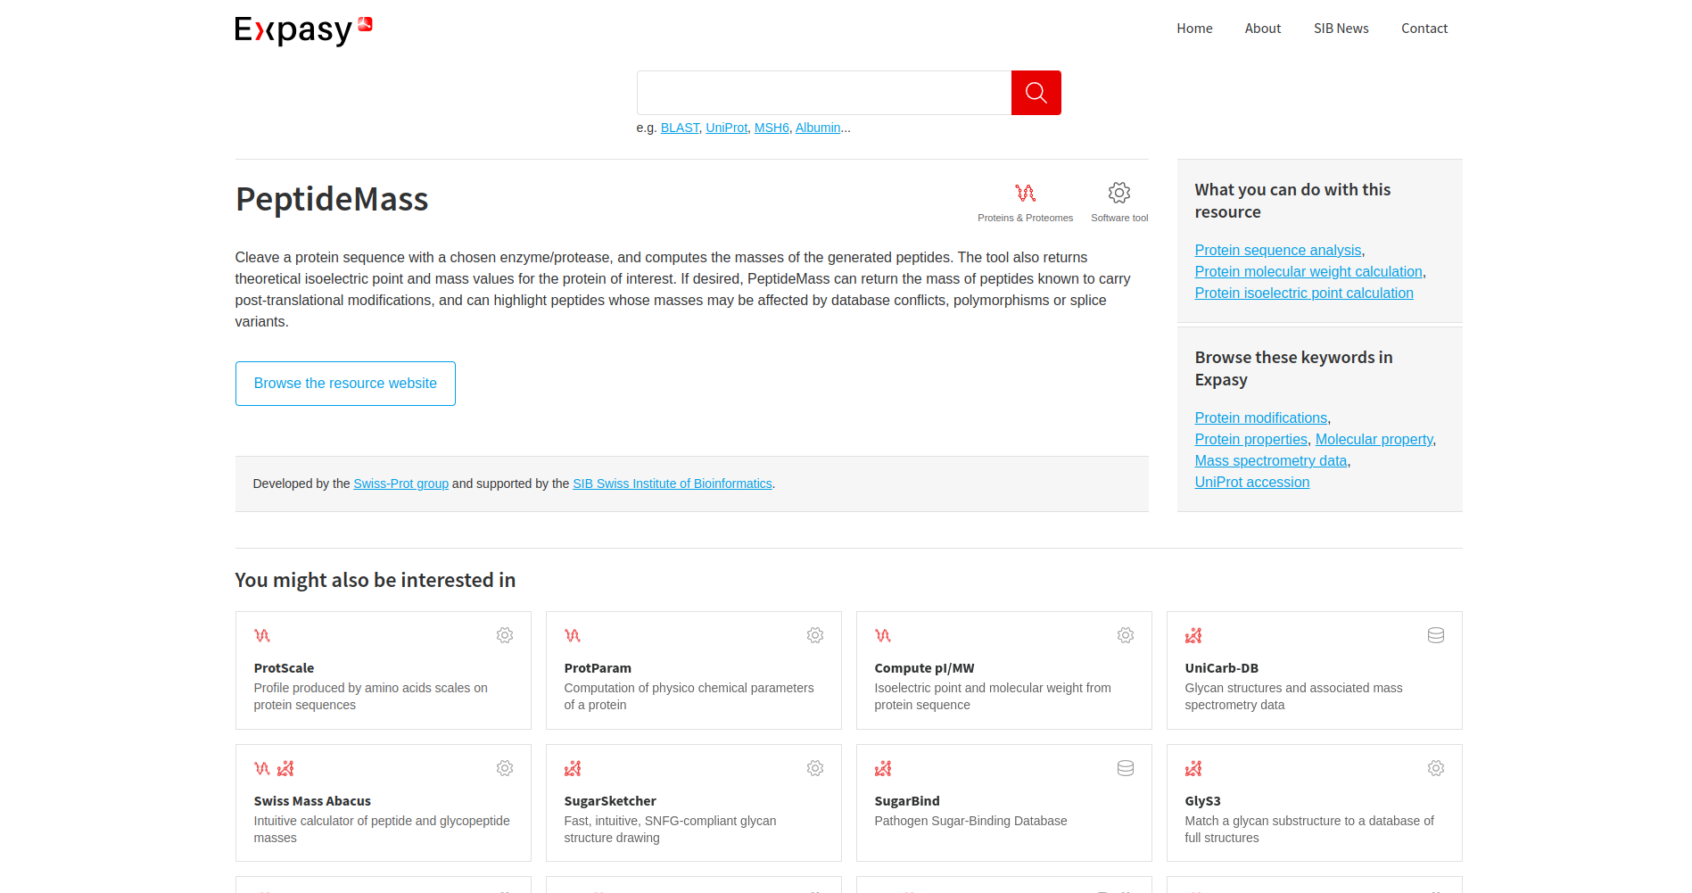Fig23. Homepage of peptidemass

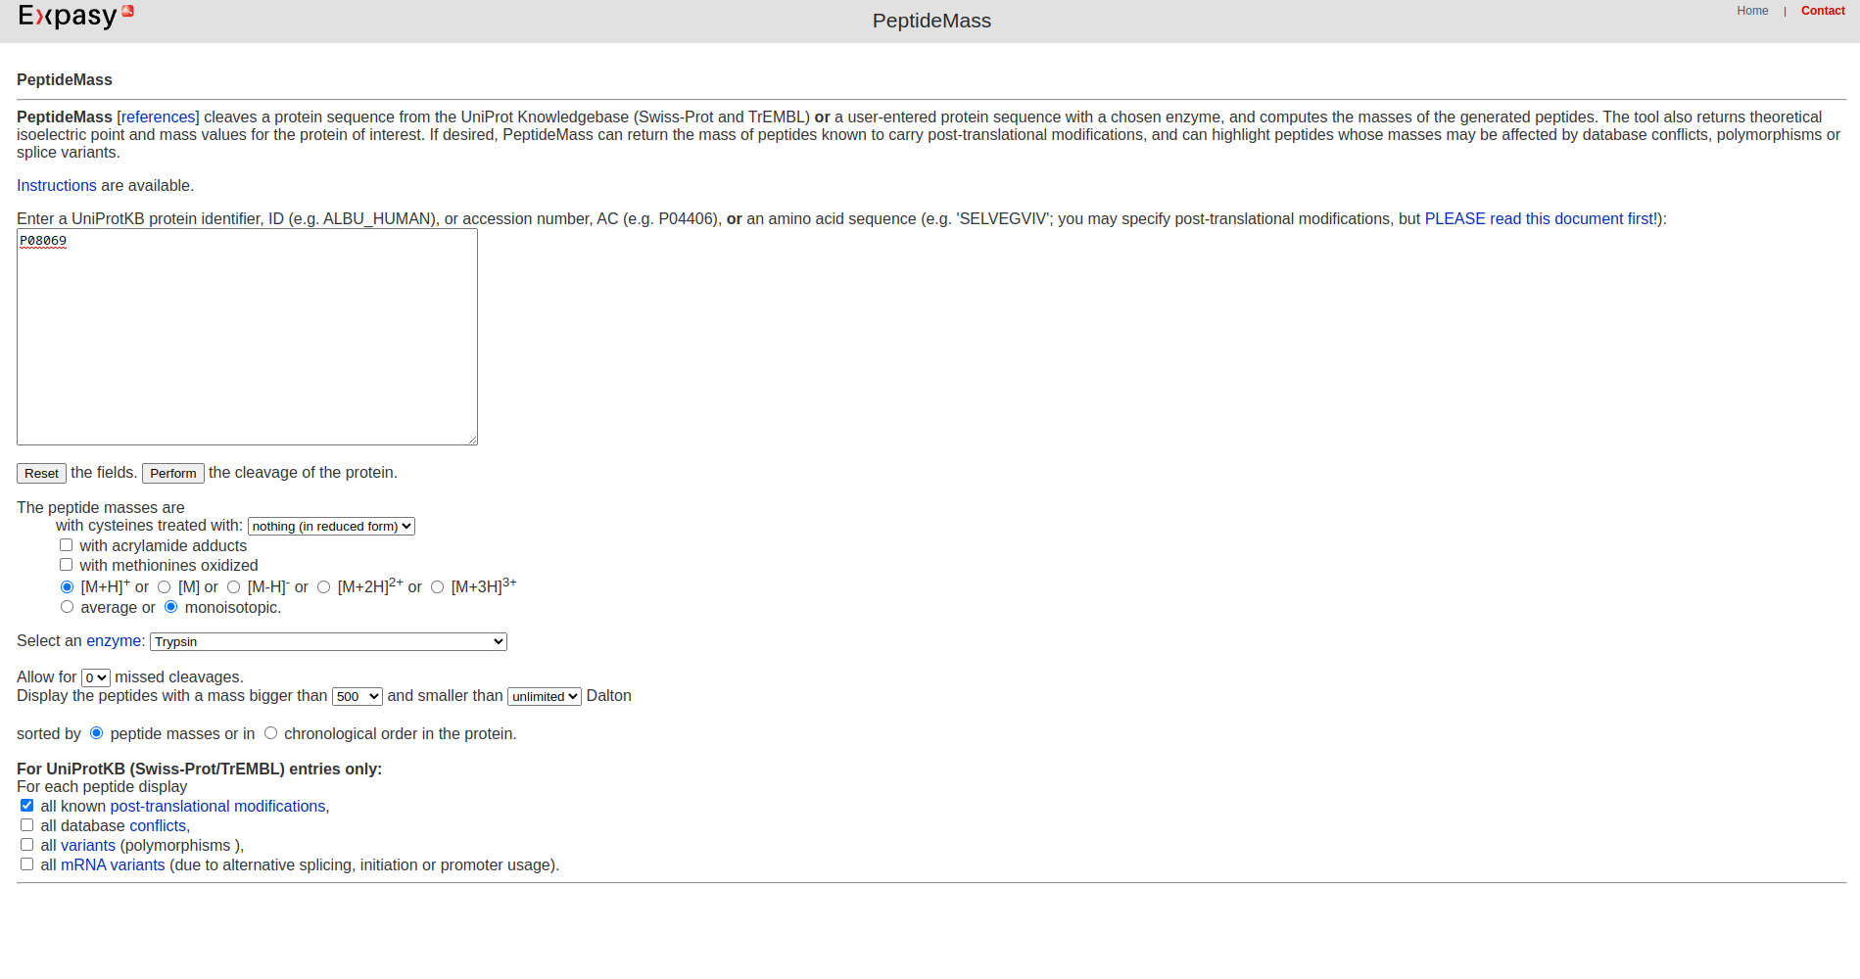Fig24. Website of PeptideMass (P08069)

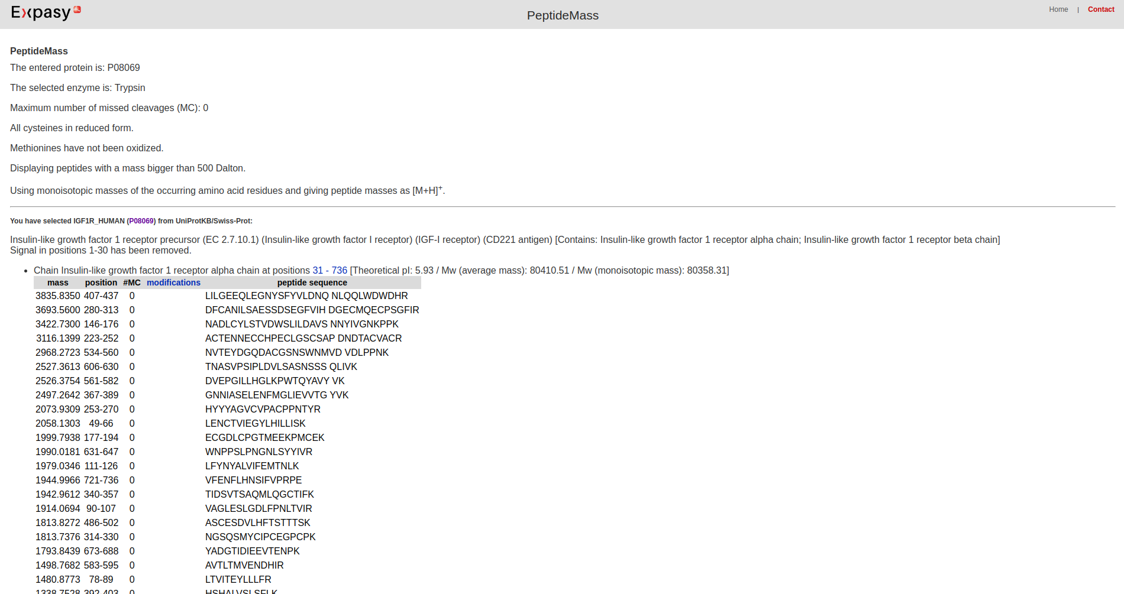Fig25. Result Page of Query

**5**

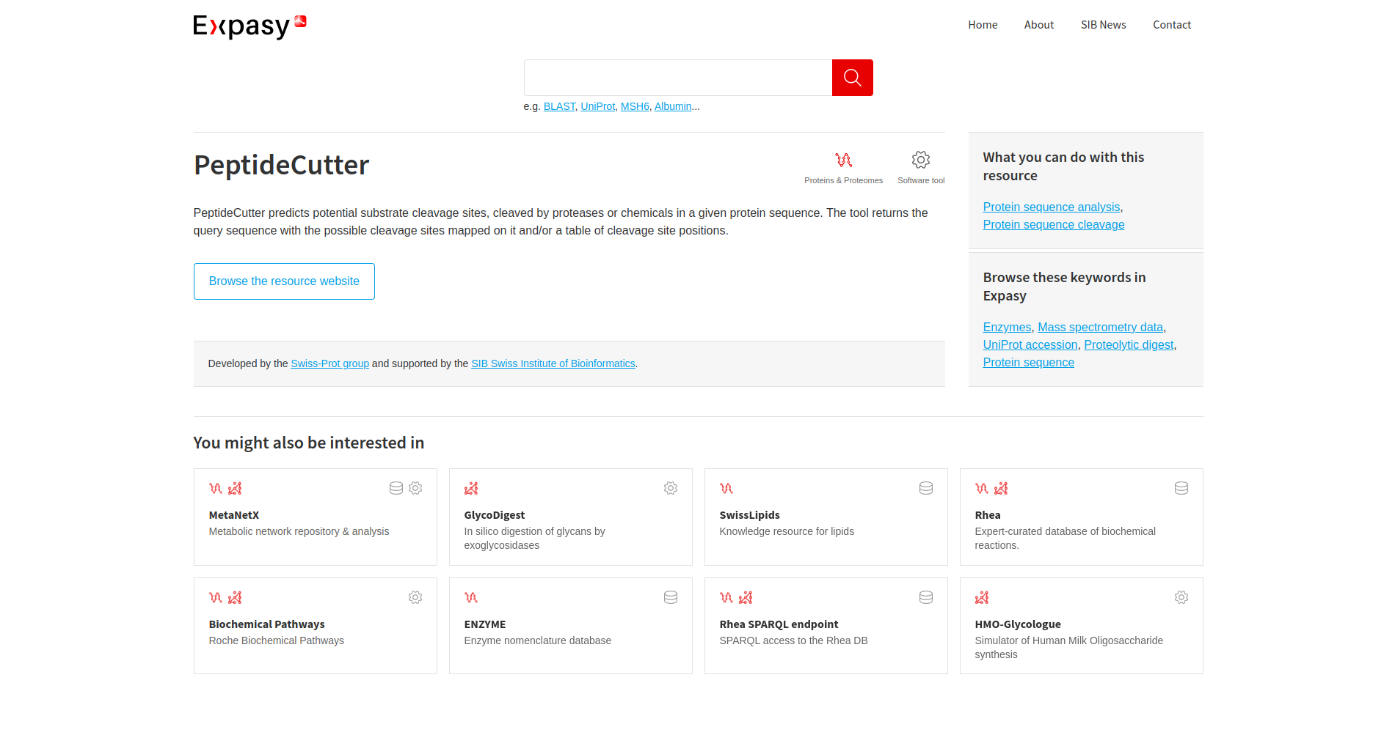Fig26. Homepage of PeptideCutter

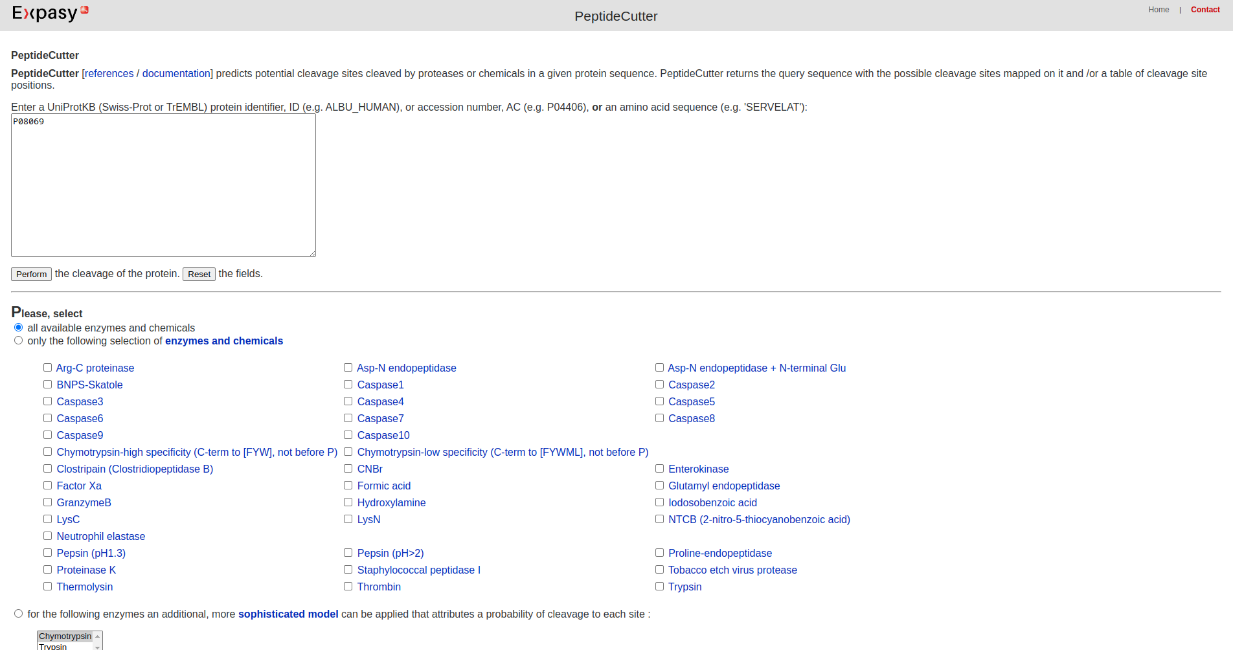Fig27. Website of PeptideCutter (P08069)

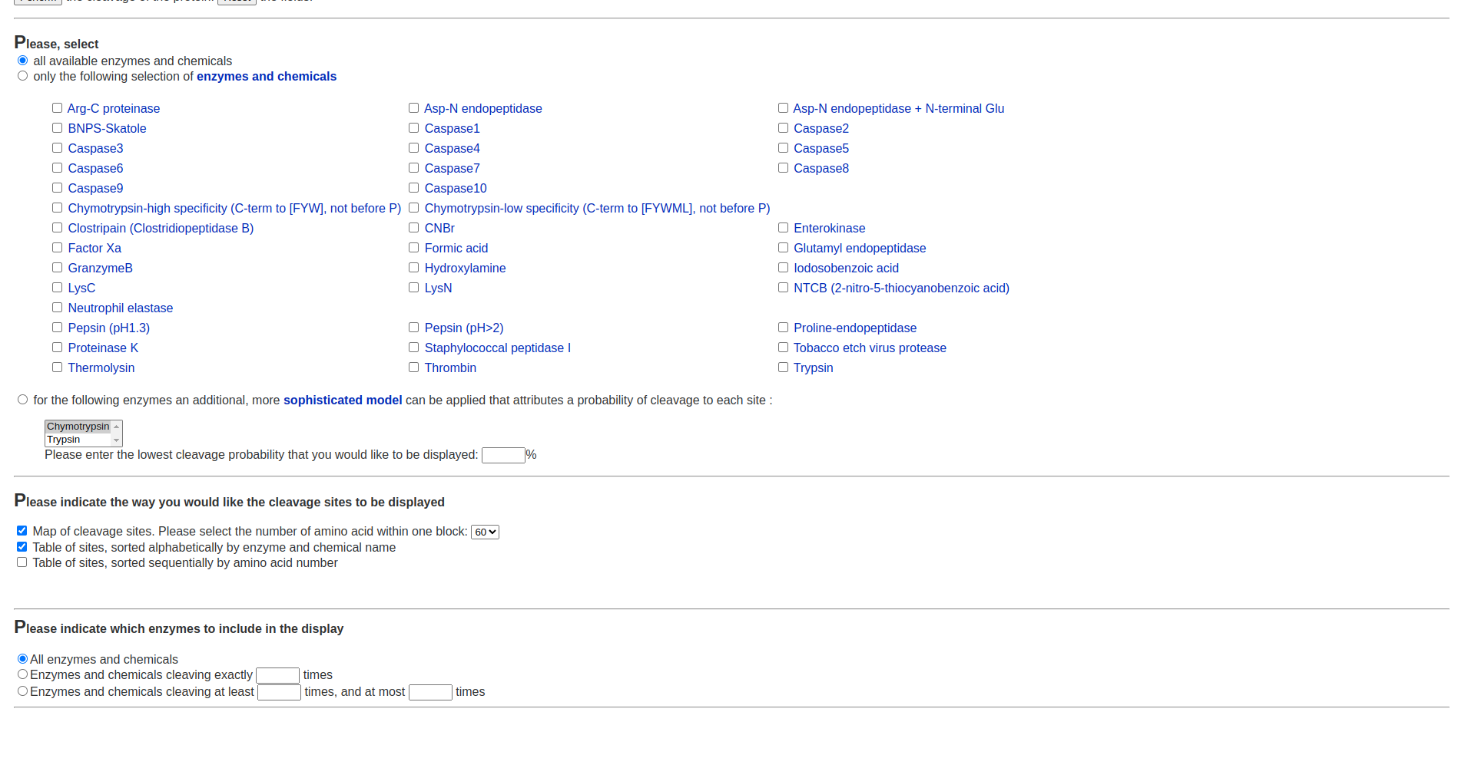Fig28. Different options of enzymes and chemicals available

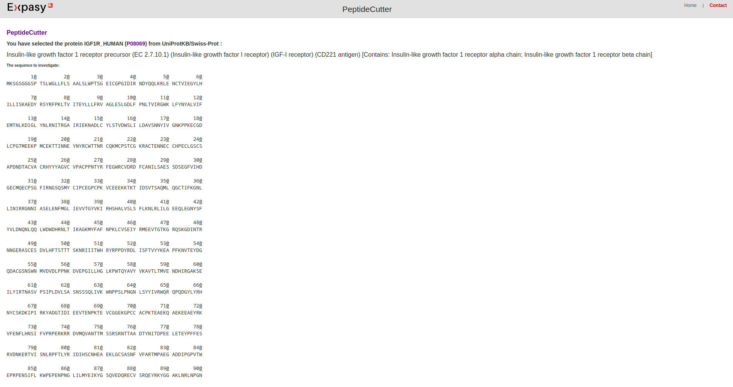Fig29. Result page of Query

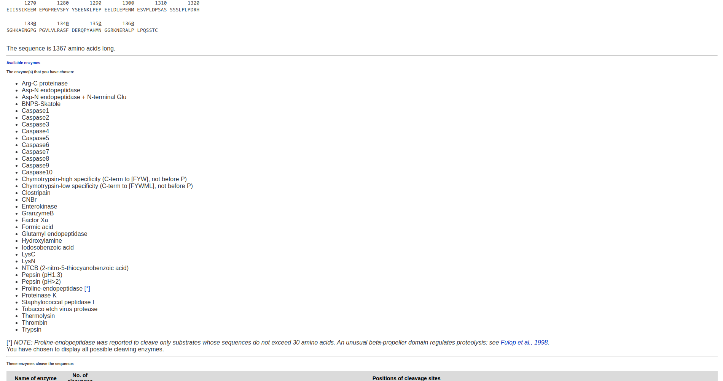Fig30. Enzymes selected while performing

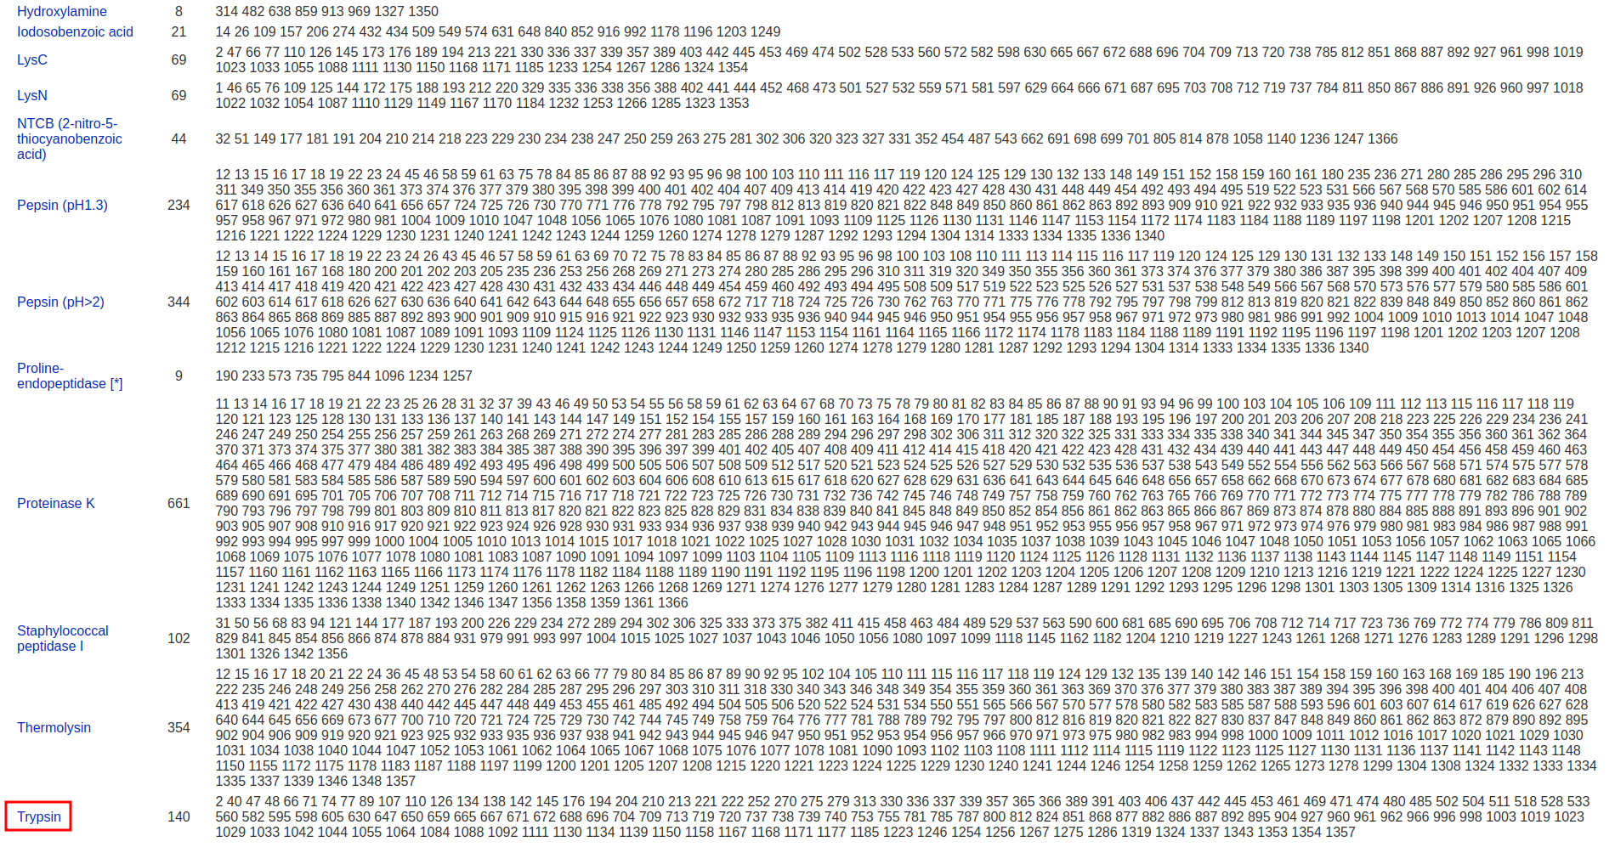Fig31. Name of Enzymes with number of cleavages and positions of cleavage sites

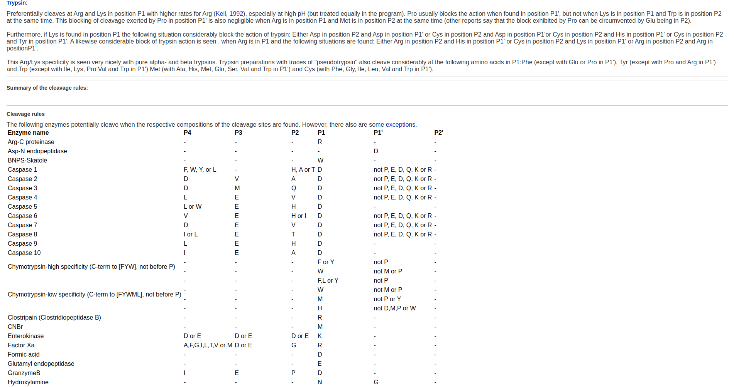Fig32. Info on Trypsin with respect to the cleavage and position of cleavage site

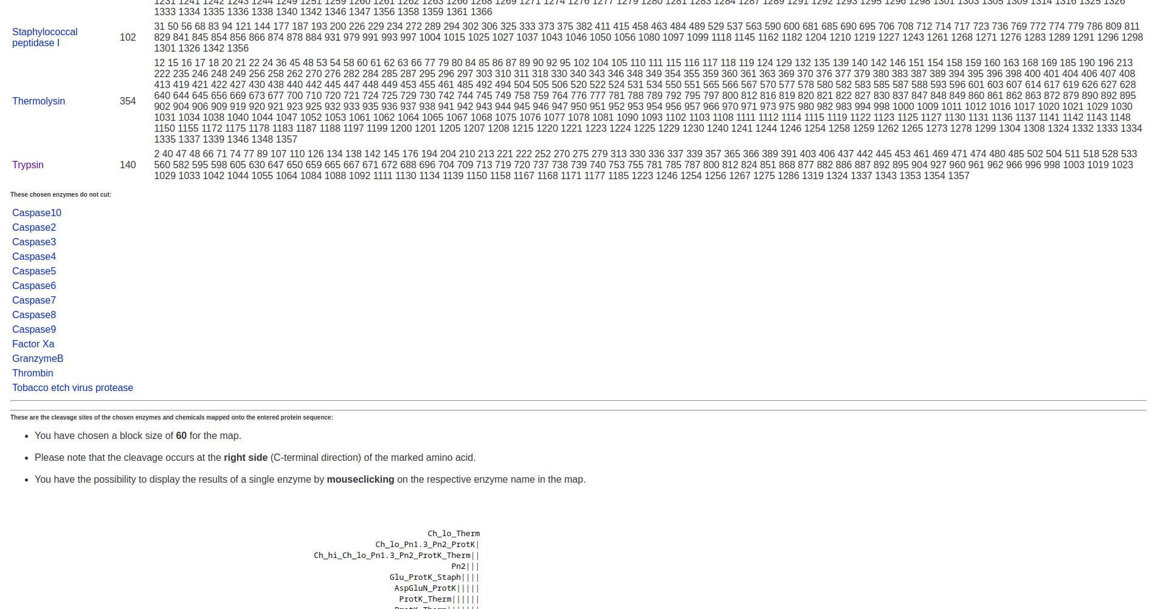Fig34. Selected enzymes that do not cut

**5. ProtScale:**

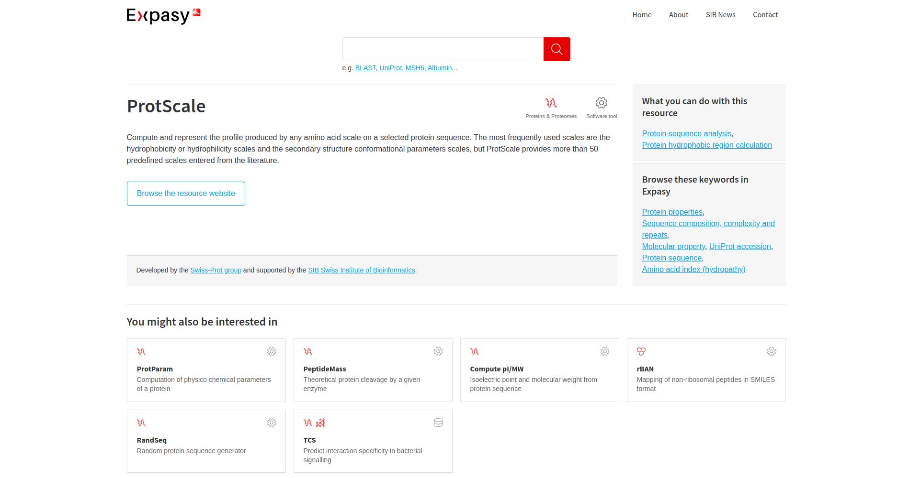Fig35. Homepage of protscale

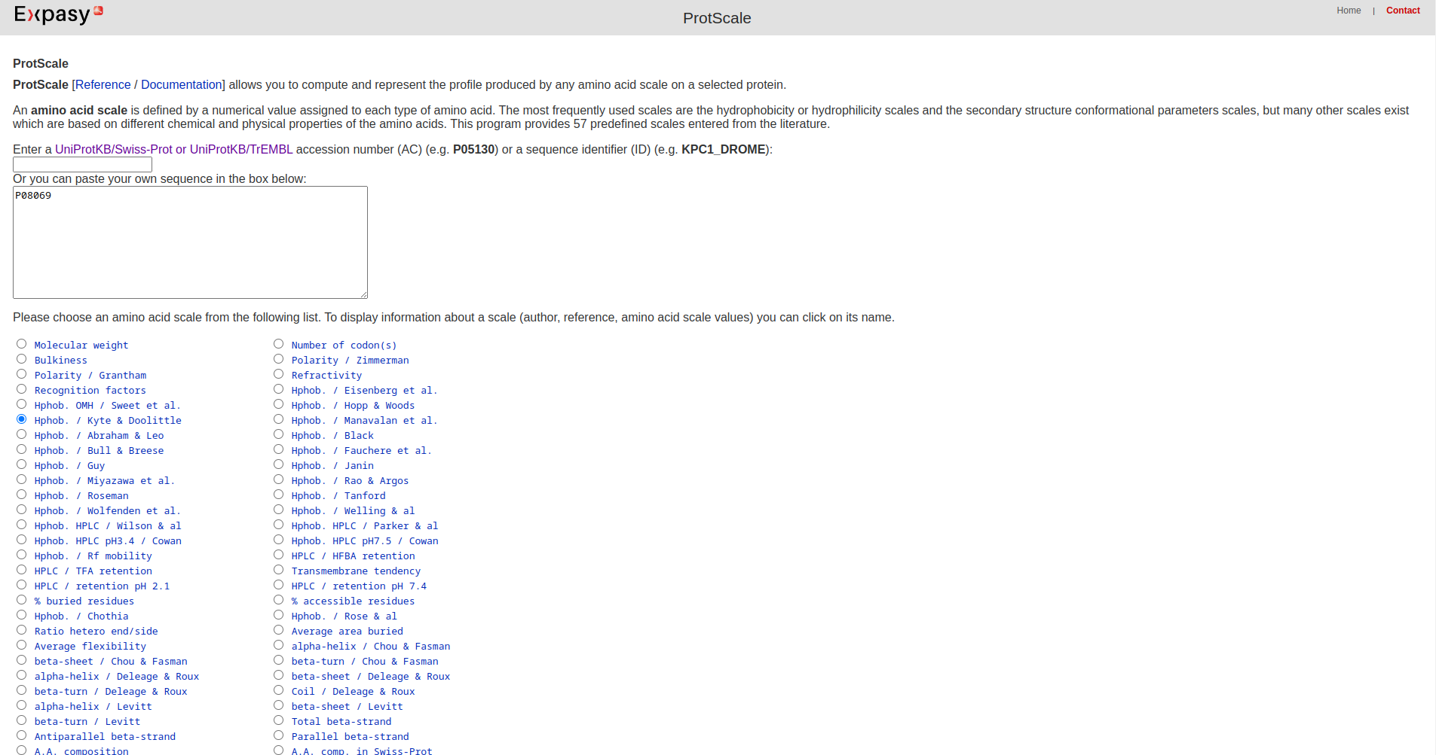Fig36. Homepage of ProtScale (P08069)

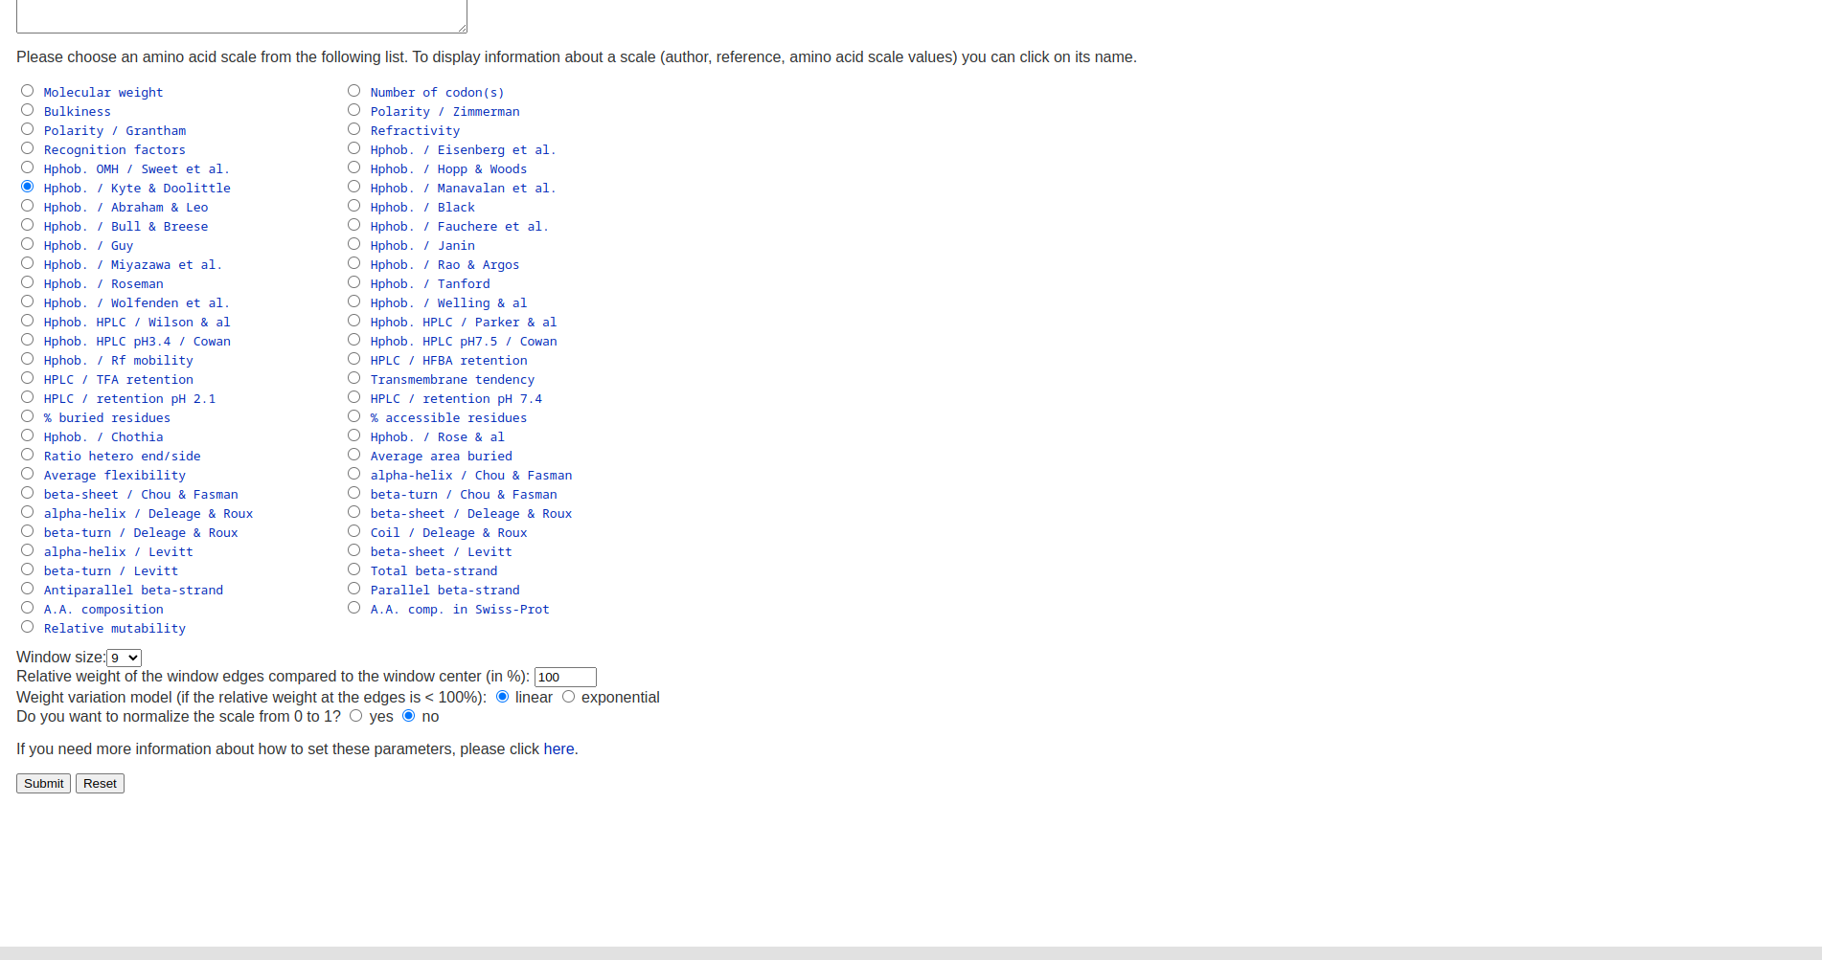Fig37. List of different amico acid scales

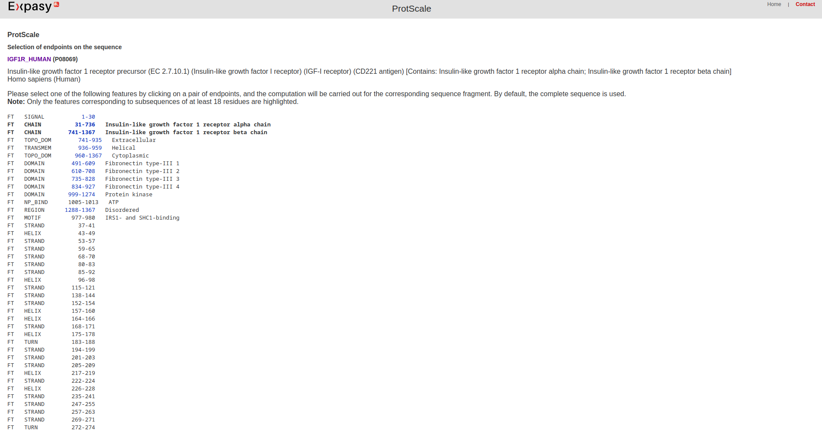Fig38. Result page of query

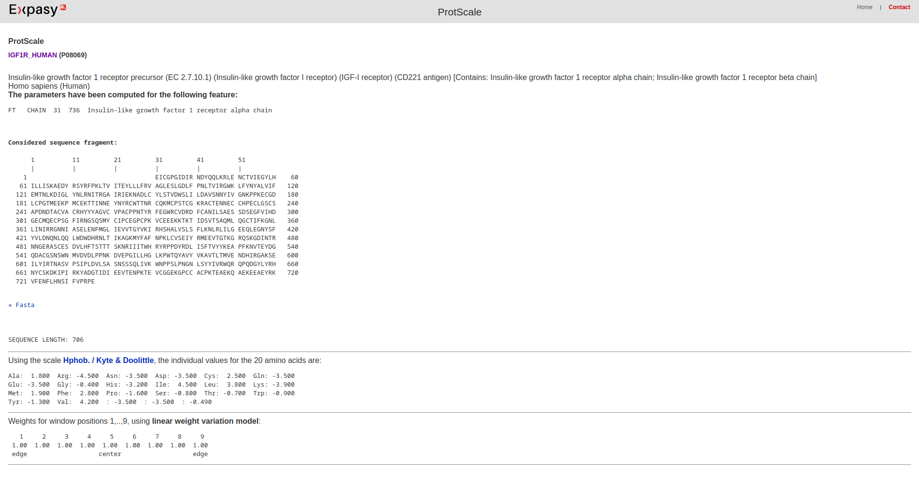Fig39. Feature Chain

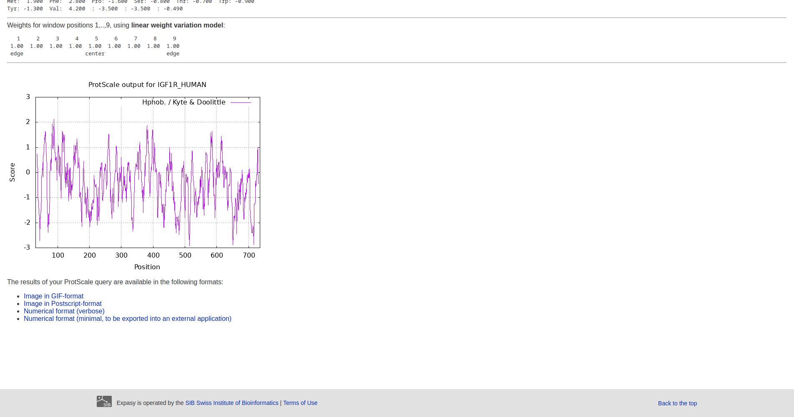Fig40. Scale Hphob /Kyle & Doolittle

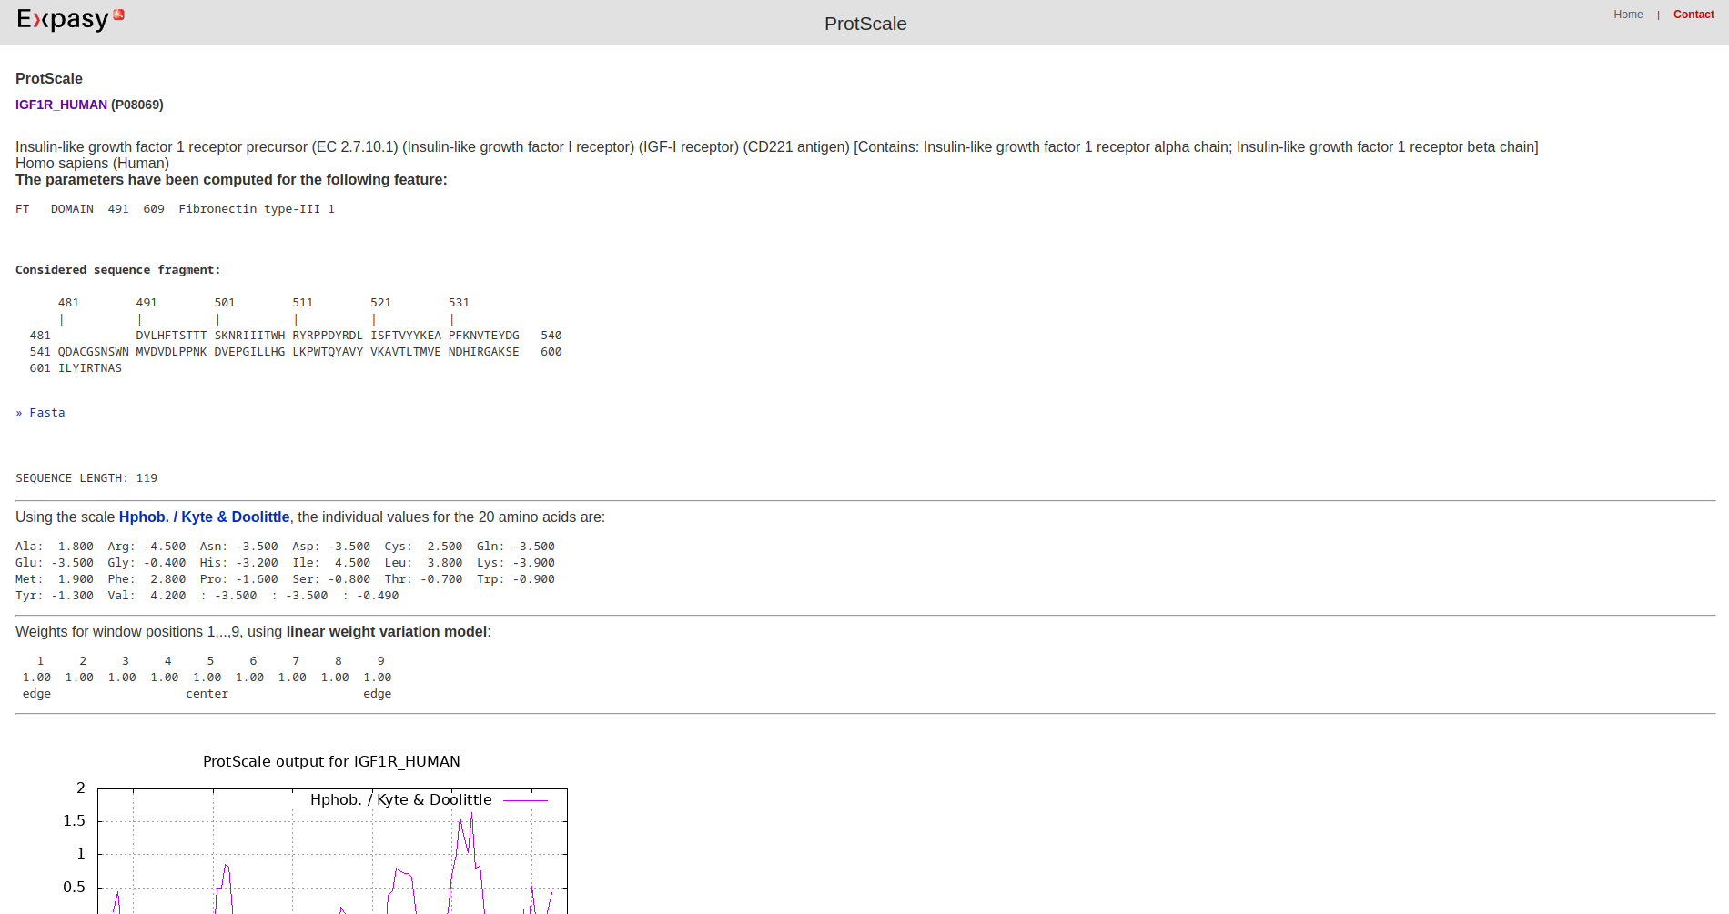Fig41. Feature Domain

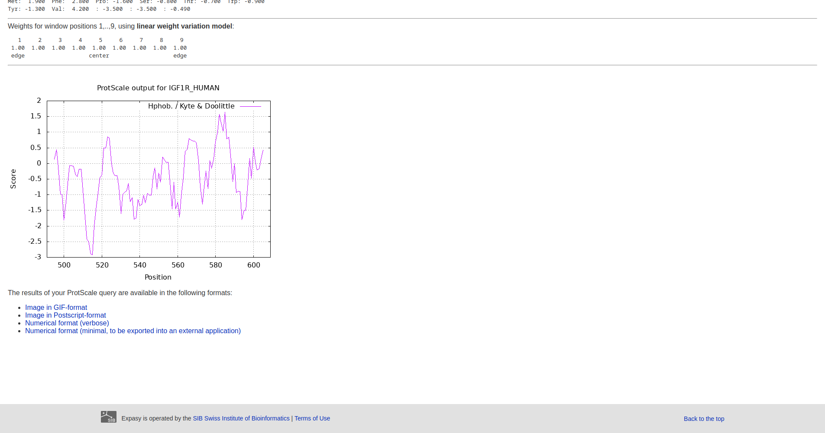Fig42. Scale Hphob Kyte & doolittle

**References:**

**Expasy Server:**

1. [**https://www.expasy.org/**](https://www.expasy.org/)

**Compute pI/MW:**

1. [**https://www.expasy.org/resources/compute-pi-mw**](https://www.expasy.org/resources/compute-pi-mw)
2. [**https://web.expasy.org/compute_pi/**](https://web.expasy.org/compute_pi/)
3. [**https://web.expasy.org/cgi-bin/compute_pi/pi_tool**](https://web.expasy.org/cgi-bin/compute_pi/pi_tool)
4. [**https://web.expasy.org/cgi-bin/compute_pi/pi_tool1?P08069@25-152@average**](https://web.expasy.org/cgi-bin/compute_pi/pi_tool1?P02701@25-152@average)
5. [**https://web.expasy.org/cgi-bin/compute_pi/pi_tool**](https://web.expasy.org/cgi-bin/compute_pi/pi_tool)
6. [**https://web.expasy.org/cgi-bin/compute_pi/pi_tool1?P08069@26-149@average**](https://web.expasy.org/cgi-bin/compute_pi/pi_tool1?P02701@26-149@average)
7. [**https://web.expasy.org/cgi-bin/compute_pi/pi_tool1?P08069@87-93@average**](https://web.expasy.org/cgi-bin/compute_pi/pi_tool1?P02701@87-93@average)
8. [**https://web.expasy.org/cgi-bin/compute_pi/pi_tool1?P08069@130-135@average**](https://web.expasy.org/cgi-bin/compute_pi/pi_tool1?P02701@130-135@average)

**ProtParam:**

1. [**https://www.expasy.org/resources/protparam**](https://www.expasy.org/resources/protparam)
2. [**https://web.expasy.org/protparam/**](https://web.expasy.org/protparam/)
3. [**https://web.expasy.org/cgi-bin/protparam/protparam**](https://web.expasy.org/cgi-bin/protparam/protparam)
4. [**https://web.expasy.org/cgi-bin/protparam/protparam1?P08069@25-152@**](https://web.expasy.org/cgi-bin/protparam/protparam1?P02701@25-152@)
5. [**https://web.expasy.org/cgi-bin/protparam/protparam1?P08069@51-58@**](https://web.expasy.org/cgi-bin/protparam/protparam1?P02701@51-58@)
6. [**https://web.expasy.org/cgi-bin/protparam/protparam1?P08069@26-149@**](https://web.expasy.org/cgi-bin/protparam/protparam1?P02701@26-149@)
7. [**https://web.expasy.org/cgi-bin/protparam/protparam1?P08069@130-135@**](https://web.expasy.org/cgi-bin/protparam/protparam1?P02701@130-135@)

**PeptideMass:**

1. [**https://www.expasy.org/resources/peptidemass**](https://www.expasy.org/resources/peptidemass)
2. [**https://web.expasy.org/peptide_mass/**](https://web.expasy.org/peptide_mass/)
3. [**https://web.expasy.org/cgi-bin/peptide_mass/peptide-mass.pl**](https://web.expasy.org/cgi-bin/peptide_mass/peptide-mass.pl)

**PeptideCutter:**

1. [**https://www.expasy.org/resources/peptidecutter**](https://www.expasy.org/resources/peptidecutter)
2. [**https://web.expasy.org/peptide_cutter/**](https://web.expasy.org/peptide_cutter/)
3. [**https://web.expasy.org/peptide_cutter/peptidecutter_enzymes.html#Tryps**](https://web.expasy.org/peptide_cutter/peptidecutter_enzymes.html#Tryps)

**ProtScale:**

1. [**https://www.expasy.org/resources/protscale**](https://www.expasy.org/resources/protscale)
2. [**https://web.expasy.org/protscale/**](https://web.expasy.org/protscale/)
3. [**https://web.expasy.org/cgi-bin/protscale/protscale.pl?1**](https://web.expasy.org/cgi-bin/protscale/protscale.pl?1)
4. [**https://web.expasy.org/cgi-bin/protscale/protscale.pl?P08069@25-152@Hphob.--/--Kyte--&--Doolittle_7_100_linear_no**](https://web.expasy.org/cgi-bin/protscale/protscale.pl?P02701@25-152@Hphob.--/--Kyte--&--Doolittle_7_100_linear_no)
5. [**https://web.expasy.org/cgi-bin/protscale/protscale.pl?P08069@26-149@Hphob.--/--Kyte--&--Doolittle_7_100_linear_no**](https://web.expasy.org/cgi-bin/protscale/protscale.pl?P02701@26-149@Hphob.--/--Kyte--&--Doolittle_7_100_linear_no)